**Task on Looping Statements (For, While, Do-While)**

**1)Write a for loop that prints all multiples of 7 from 1 to 70.**

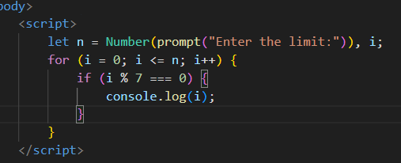**CODE :** <script>

        let n = Number(prompt("Enter the limit:")), i;

        for (i = 0; i <= n; i++) {

            if (i % 7 === 0) {

                console.log(i);

            }

        }

    </script>

**2)Convert the following while loop into a for loop:**

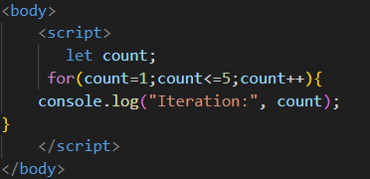**let count = 1;**

**while (count <= 5) {**

**console.log("Iteration:", count);**

**count++;**

**}**

**CODE:**<script>

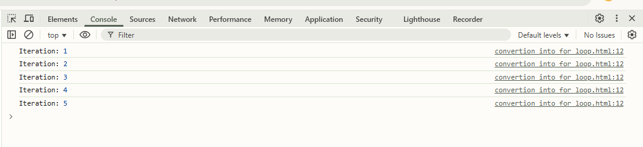       let count;

     for(count=1;count<=5;count++){

    console.log("Iteration:", count);

}

    </script>

**3)What will be the output of this do-while loop? Explain why.**

**let num = 10;**

**do {**

**console.log("Current number:", num);**

**num -= 2;**

**} while (num > 0);**

**OUTPUT:** Current number: 10,

**Fizz-Buzz Problem**

**4)Modify the Fizz-Buzz program to print "Boom" if the number is divisible by 7.**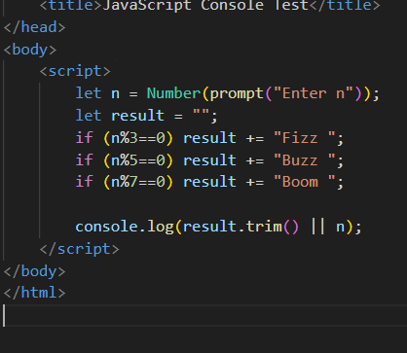

**Example: 7 → Boom, 21 → Fizz Boom, 35 → Buzz Boom**

**CODE** :   <script>

        let n = Number(prompt("Enter n"));

        let result = "";

        if (n%3==0) result += "Fizz ";

        if (n%5==0) result += "Buzz ";

        if (n%7==0) result += "Boom ";

        console.log(result.trim() || n);

    </script>

**5)What will be the output of this code?**

**for (let i = 20; i <= 30; i++) {**

**if (i % 4 === 0) console.log(i, "Four");**

**if (i % 6 === 0) console.log(i, "Six");**

**}**

**OUTPUT :** 20 'Four'

24 'Four'

24 'Six'

28 'Four'

30 'Six'

**Equality Operators & Variable Concepts**

**6)What is the difference between == and ===? Give an example where == gives false but === gives true.**

== is the equality operator, while === is the strict equality operator. The main difference between the two is that == performs type conversions, while === does not.

|  |  |  |
| --- | --- | --- |
|  | == | === |
| What it does | Compares values, performing type conversions if needed | Compares values and types |
| When it returns true | If values are equal, after type conversions | If values are equal and of the same type |

**EXAMPLE :**

let a = 0;

let b = false;

console.log(a == b); // true (0 is loosely equal to false)

console.log(a === b); // false (0 is a number, false is a boolean)

**7)Predict the output:**

**console.log(null == undefined);**

**console.log(null === undefined);**

**console.log("10" == 10);**

**console.log("10" === 10);**

OUTPUT:   
true

false

true

false

**Array Methods**

**8)What will be the output of the following array operations?**

**let colors = ["red", "blue", "green"];**

**colors.unshift("yellow"); *//OUTPUT : ["yellow", "red", "blue", "green"]***

**colors.splice(2, 1, "purple"); *//OUTPUT: ["yellow", "red", "purple", "green"]***

**console.log(colors);**

**What does .unshift() do?**

**ANS:** The .unshift() method adds one or more elements to the beginning of an array and returns the new length of the array

**What does .splice(2, 1, "purple") do?**

**ANS:** The .splice() method modifies an array by adding, removing, or replacing elements.

**9)Write a function that removes all even numbers from an array using the .filter() method**.

**let numbers = [10, 15, 20, 25, 30, 35];**

**// Expected Output: [15, 25, 35]**

**CODE:**

function remEven(arr) {

return arr.filter(num => num % 2 !== 0);}

let numbers = [10, 15, 20, 25, 30, 35];

let result = remEven(numbers);

console.log(result); ***// Output: [15, 25, 35]***

**10)Write a function to check if a number is a palindrome.**

**isPalindrome(12321) // true**

**isPalindrome(45654) // true**

**isPalindrome(12345) // false**

**CODE :**

      function isPalindrome(num) {

    let originalNum = num;

    let rem, reverseNum = 0;

    while (num > 0) {

        rem = num % 10;  // Get last digit

        reverseNum = (reverseNum * 10) + rem; // Build reversed number

        num = Math.floor(num / 10); // Removess last digit

    }

    return reverseNum === originalNum;

} if (reverseNum === originalNum) {

        console.log('Palindrome!');

    } else {

        console.log('NOT a Palindrome.');

    }